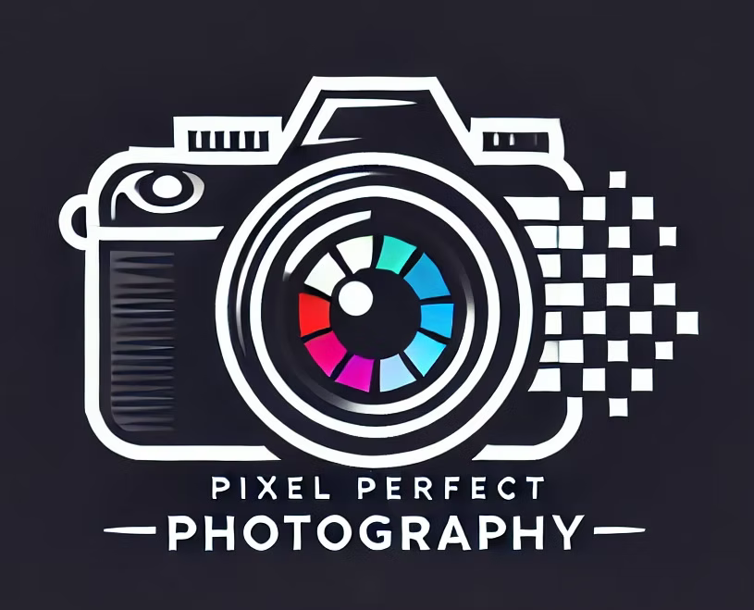
FOR IMMEDIATE RELEASE
Media Contact:
Stephanie Vargas-Diaz
Public Relations Representative
Pixel Perfect Photography
svdpixelpirfect@yahoo.com
(407) 747-1654

Pixel Perfect Photography Expands Services and Visibility
CONCORD, N.C. — August 26, 2026 — Pixel Perfect Photography, a locally owned photography business founded by Jordan Block in 2023, is expanding its services and community presence throughout the Concord and Charlotte area. The business is increasing its focus on corporate photography, events and destination weddings while continuing to provide portrait and commercial photography services.
The expansion comes as small businesses continue to play an important role in communities across the United States. According to the U.S. Small Business Administration, small businesses represent 99.9% of all U.S. businesses and employ 62.3 million people.
Pixel Perfect Photography has grown primarily through word-of-mouth referrals and strong client relationships. The company's next step is to increase brand awareness and connect with more individuals, couples, businesses and organizations throughout the Concord and Charlotte area.
"Photography is about more than taking a picture. It's about creating an experience and capturing moments that people and businesses can remember and share," said Jordan Block, founder and owner of Pixel Perfect Photography.
The company's expansion will focus on building relationships with local businesses, wedding professionals and community organizations while increasing its digital and media presence. Pixel Perfect Photography hopes to become a trusted photography resource for individuals and organizations looking for professional, personalized photography services.
Press Release and Five-Photo Media Gallery:
Media Page
###

About Pixel Perfect Photography
Pixel Perfect Photography is a locally owned photography business based in Concord, North Carolina. Founded by Jordan Block in 2023, the company provides portrait, event and commercial photography services. Pixel Perfect Photography is committed to creating high-quality images while providing clients with a professional and personalized experience. The company is expanding its services throughout the Concord and Charlotte area with a focus on corporate photography, events and destination weddings.

